12.50: Denote the 25-kg sphere by a subscript 1 and the 100-kg sphere by a subscript 2. a) Linear momentum is conserved because we are ignoring all other forces, that is, the net external force on the system is zero. Hence, 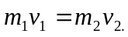 This relationship is useful in solving part (b) of this problem. b)From the work-energy theorem,
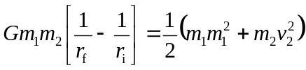
and from conservation of momentum the speeds are related by 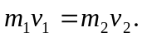 Using the conservation of momentum relation to eliminate 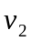 in favor of 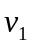 and simplifying yields
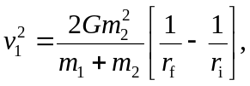
with a similar expression for . Substitution of numerical values gives The magnitude of the relative velocity is the sum of the speeds, 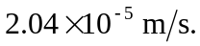
c) The distance the centers of the spheres travel 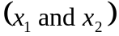 is proportional to their acceleration, and 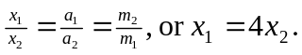 When the spheres finally make contact, their centers will be a distance of 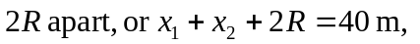
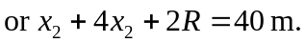 Thus,

